OSSP:
Commands:
uname : Displays basic operating system information.
lscpu : Displays CPU and processor details.
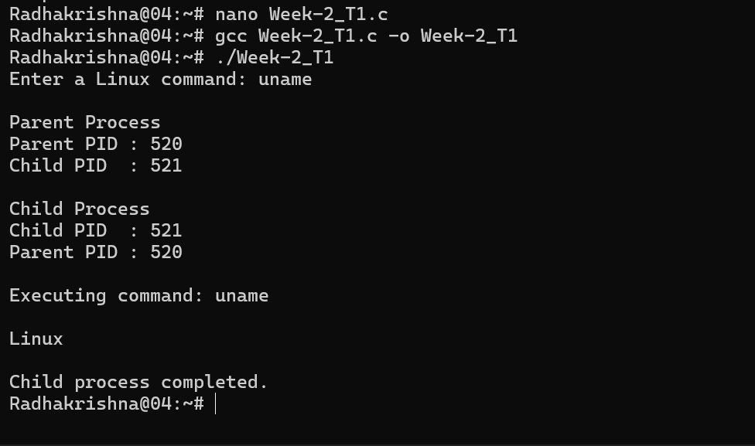

ps : Displays the currently running processes.
2520090063
R. Radha Krishna

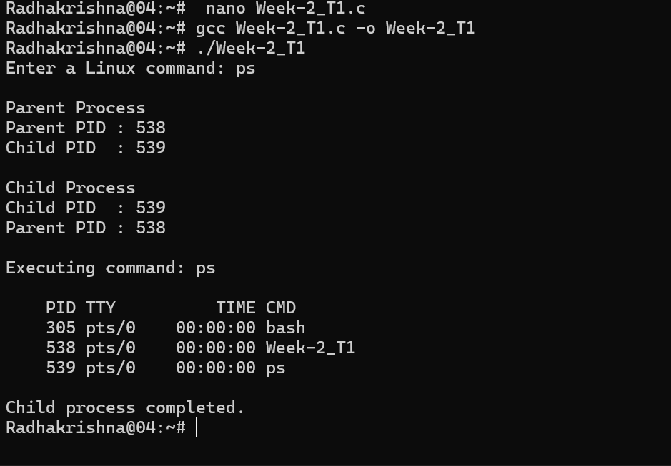

Relation Between Hardware Resources and Operating System Services:
- CPU
The operating system manages the CPU by dividing its processing time among multiple applications.
Example: When we open Chrome and a music player together, the OS schedules CPU time for both.It Process Both Chrome And music player

- Memory (RAM) -> Memory Management
The operating system assigns a separate portion of RAM to every running application.
Example: Chrome and VS Code each get their own memory space while running.

- Storage (SSD) → File System Management
The operating system storesand organizes files on the storage device. Example: Saving a document in the Documents folder on our computer.

- I/O Devices → Device Management
The operating system uses device drivers to control input and output devices.

